An Efficient Algorithm for Row Minima Computations on Basic Reconfigurable Meshes
Koji Nakano, Member, IEEE, and Stephan Olariu, Member, IEEE

IEEE TRANSACTIONS ON PARALLEL AND DISTRIBUTED SYSTEM, VOL. 9, JUNE 1998, pp. 561-569

Abstract
The problem of computing the minima of monotone matrix is import in image processing, pattern recognition, text editing , facility location, optimization , and VLSI. Our row-minima algorithm runs in O(logn) time if 1≦m≦2 and in O(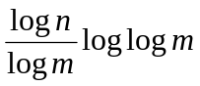)time if m > 2.

Introduction
Matrix A is termed monotone if ,for every , ,1≦≦≦m, the smallest value in row lies below or to the right of the smallest value in row .
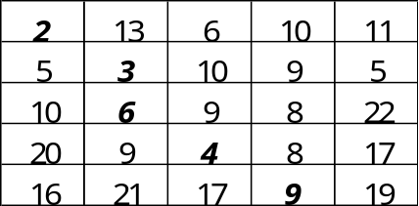
- Prefix-Maxima-1
2-1. O(1) time for computing the prefix maxima of n items on a BRM of size n x n .
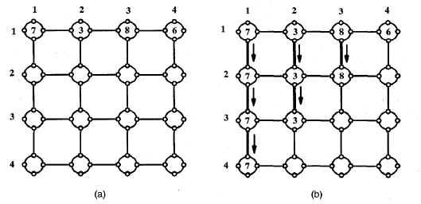
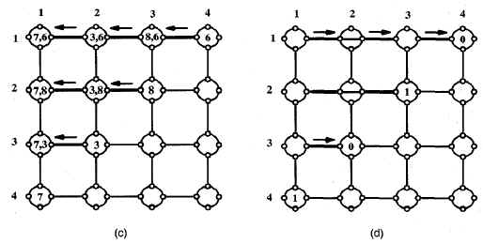
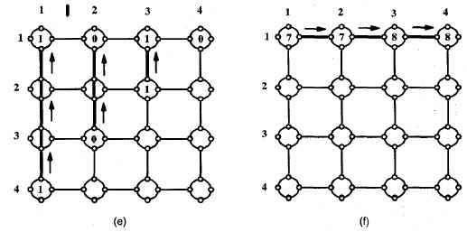
2-2. O(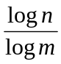) time for computing the prefix maxima of n items in one
row of a BRM of size m x n with 2≦m≦n.
- Selective-Row-Minima
Step1.
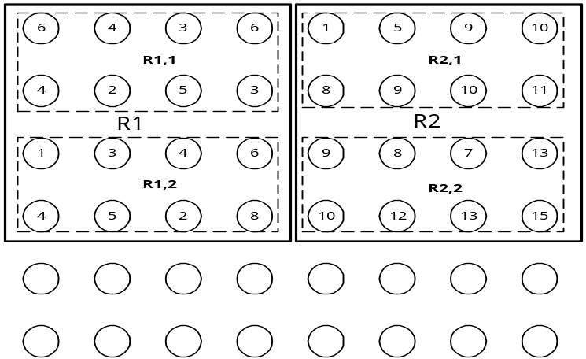
Step2.
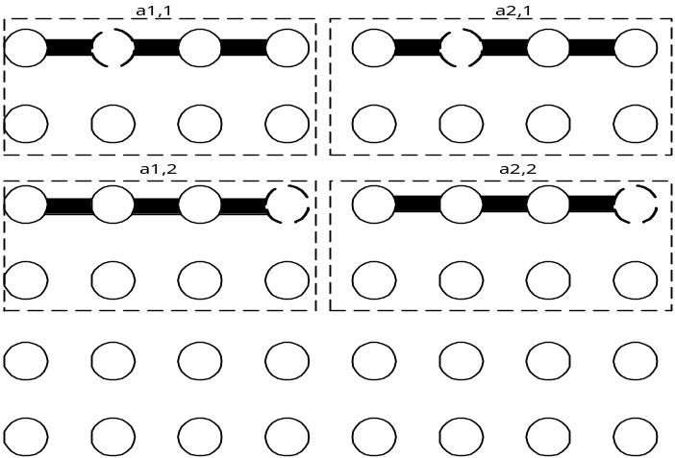
Step3.
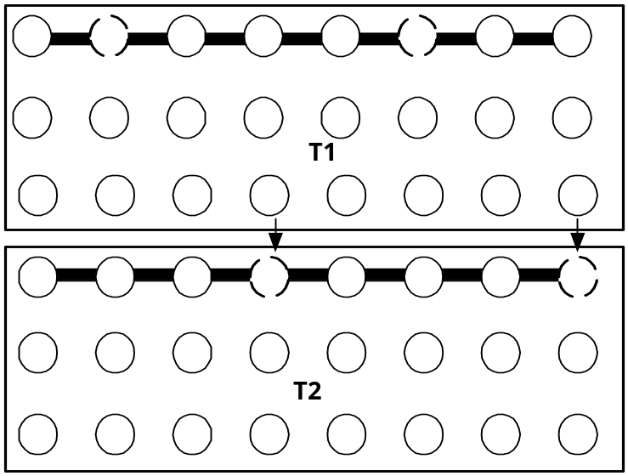
Step4. Using the 2-2. ,the compute the minimun in the first row of each
T_{i} in O(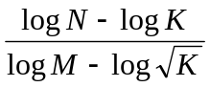) = O(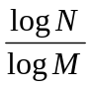) time.
- Row-Minima
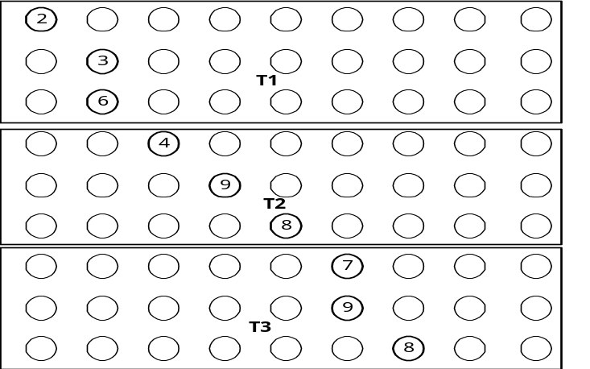
Step1.

Step2.
Using selective Row
Minima compute the minima of the itms in the first row in O() time.

Step3.
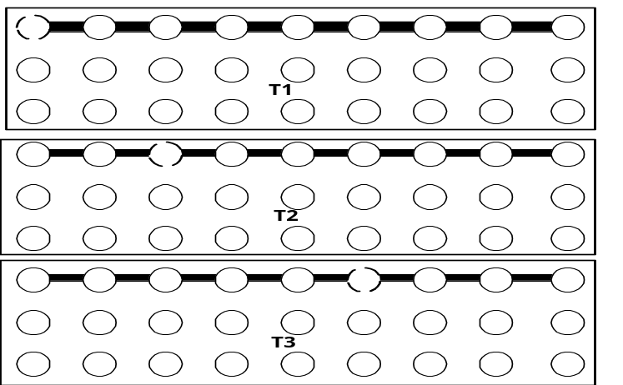
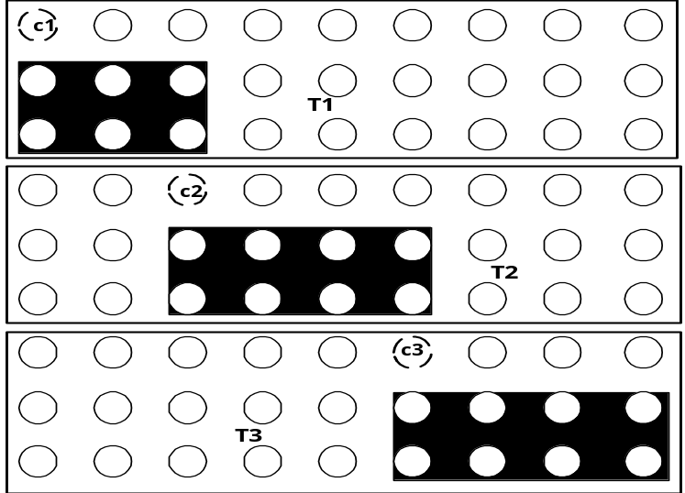
Step4. For log log m iterations ,repeat Step 1-3 above in each submesh.
- Concluding Remarks

Created by :Kuen-Feng Huang
Date : Feb. 22, 2000

